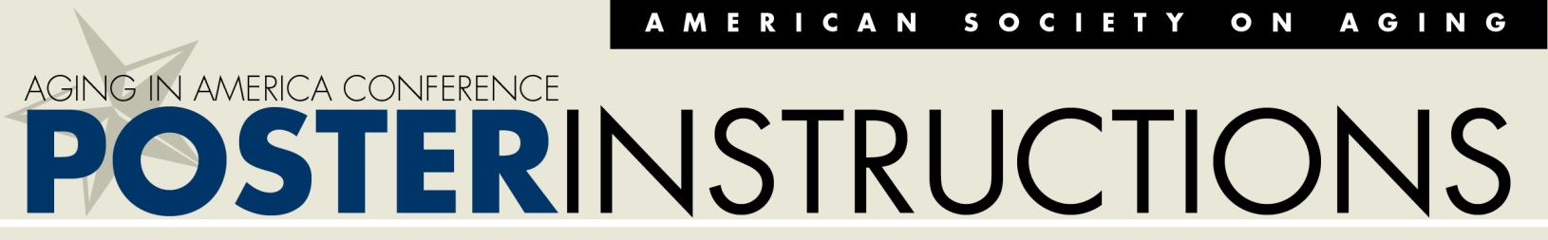
Thank you for being part of the 2019 Aging in America Conference (AiA19) as a poster presenter. We look forward to welcoming you to New Orleans April 15-18! The instructions below will help you create an effective poster and prepare for a successful presentation.
Poster presentations are two hours long and are the featured educational event from 8:30 to 10:30 AM on Wednesday, April 17.
During your presentation, you will have the opportunity to engage in informal discussion with attendees interested in your poster. This setting is a more intimate forum than workshops and often allows for more in-depth exchanges between presenters and their audience. Conference attendees will also be able to view your poster online.
As you begin to prepare your presentation, concentrate on two or three of the most important messages you want to convey. These might be your main objectives, most impactful outcomes, or the long-term goals of your project or program. Prioritize your ideas so that you can present your audience with the main ideas you want them to remember.
Once you have clarified the objectives of your presentation, you can begin to organize it to create an effective poster. Your poster should be laid out logically with an opening, body and conclusion.
Don’t crowd too much information onto your poster and avoid overwhelming the audience with too much information. Stay focused on your main objectives and keep it simple.
Summary:
- Prioritize your presentation into two to three “take-aways”
- Keep your poster and presentation simple
If you have any questions, please contact, facultyinfo@asaging.org

The easiest way to create your poster is to use PowerPoint and design a single slide that is 48 inches wide by 36 inches high. The orientation of the slide must be set to “Landscape” and images should have a resolution of at least 1,200 DPI. (How to determine the resolution of an image.)
Click here to download a template you can use as a starting point. We have also provided some sample layouts on the following page.
Some Basics:
- The required dimensions are 48 inches wide by 36 inches high and orientation is “Landscape”
- Keep your title short and use a large font size (at least 108 points)
- Avoid using font sizes smaller than 24 points
- Save your file as a PowerPoint or PDF

We will review, print, ship, and hang your poster for you at AiA19. This service is free with your conference registration. In order to have your poster printed, save your file as “PresentationTitle-LastName” (ie Older-Adults -Pets-Smith) and upload it by January 18, 2019.
If you miss the January 18 deadline, you can have your poster printed at your expense and bring it with you to the conference. You should turn it in at the registration desk no later than Tuesday, April 16, at 12:00 PM.
If you would like to keep your poster, simply take it down immediately after the session ends. (Bring your own cardboard tube for easy transport.) If you do not wish to keep your poster, leave it hanging and we will discard it for you after your session.

